**Steps to customize tflite model.**

* This article has almost every step covered.

<https://medium.com/over-engineering/building-a-custom-machine-learning-model-on-android-with-tensorflow-lite-26447e53abf2>

**Steps**

1.) git clone https://github.com/googlecodelabs/tensorflow-for-poets-2

2.) cd tensorflow-for-poets-2

Or

1.) Go to <https://github.com/googlecodelabs/tensorflow-for-poets-2> and click on the clone or download in right hand side download zip, extract zip files in one folder

2.) Change your current directory in that folder in cmd (e.g. cd C:\Users\Arjun\Desktop\New folder\tensorflow-for-poets-2 (where tensorflow-for-poets-2 is the new folder created))

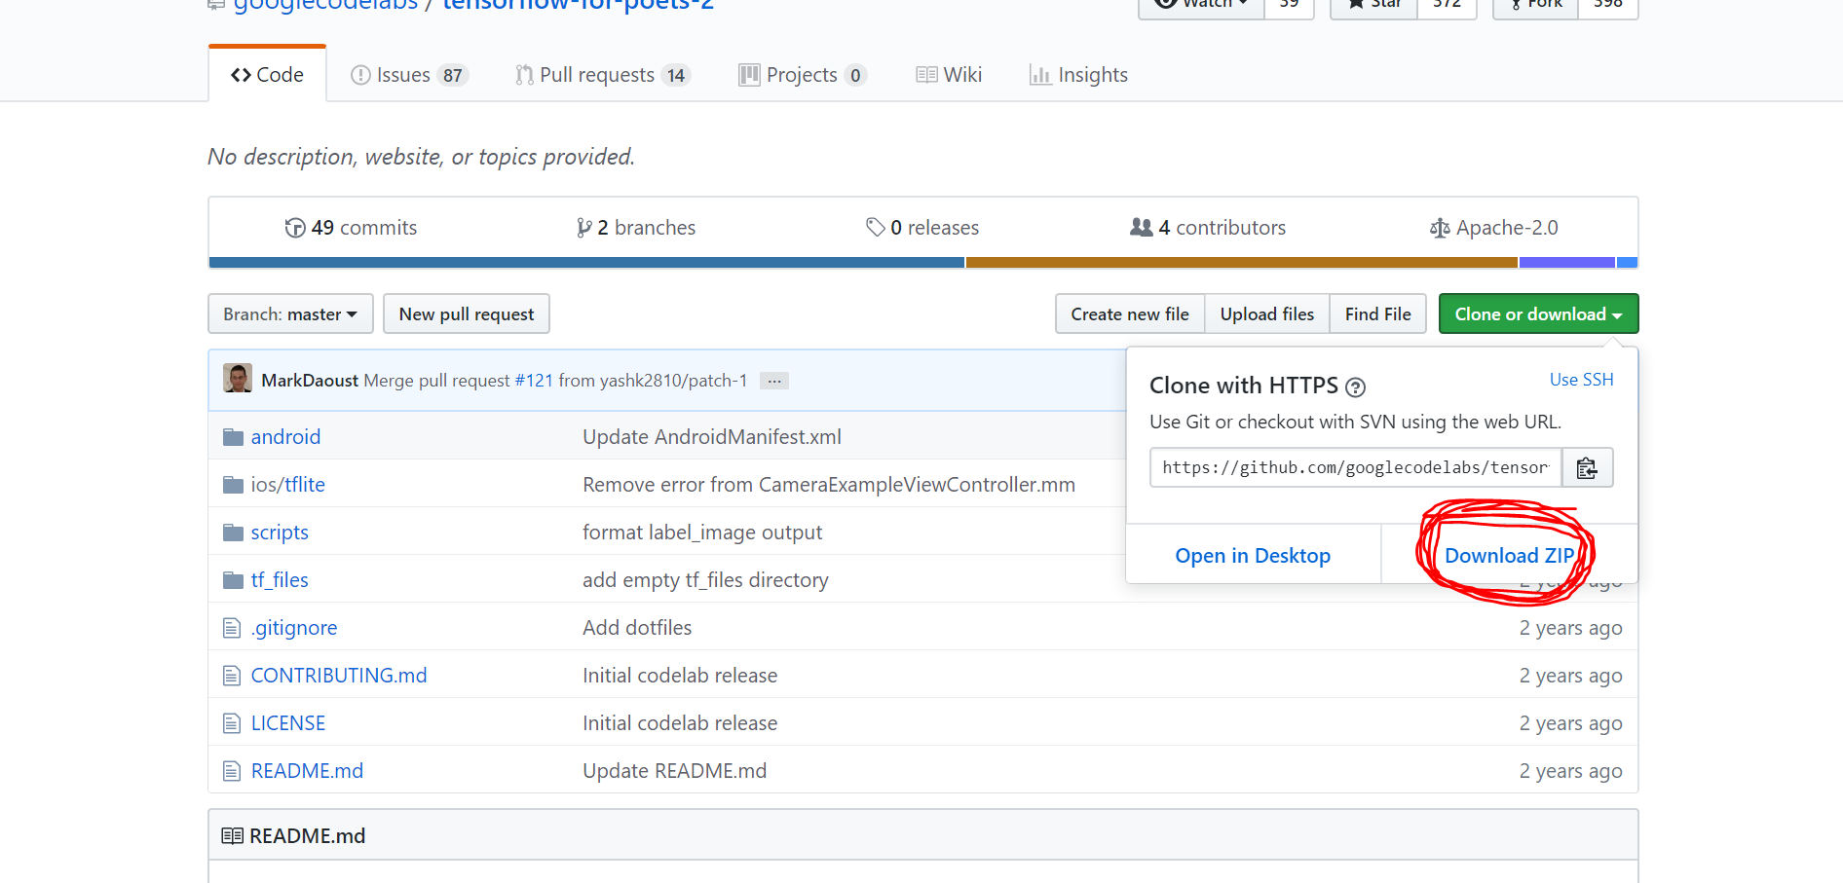

3.) Once all this done the folder will look like this.

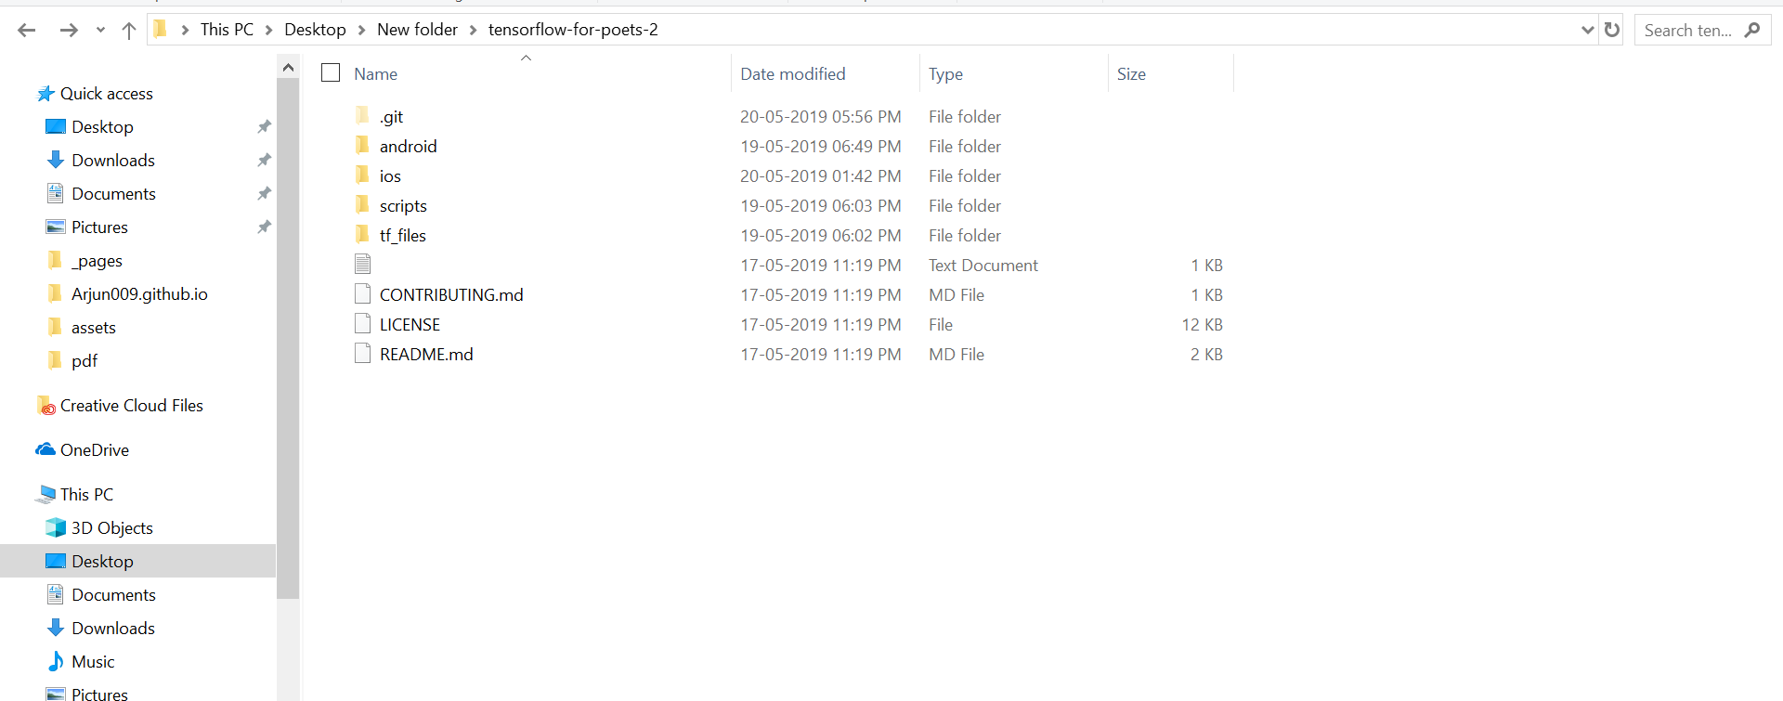

Go to scripts folder and you will find one **retrain.py** file.

Open cmd change your directory to this scripts folder.

Here e.g. cd C:\Users\Arjun\Desktop\New folder\tensorflow-for-poets-2\scripts

4.) Make sure that python is installed with TensorFlow library so that you can use it directly from cmd.

Since all this thing I had done from cmd. You can run this script directly, but you need to go through the entire code to change the default parameter.

5.) Now make one folder indian_notes which will contain your label wise folder of images.

It should look like this.



Inside your indian_notes folder it should look like this.

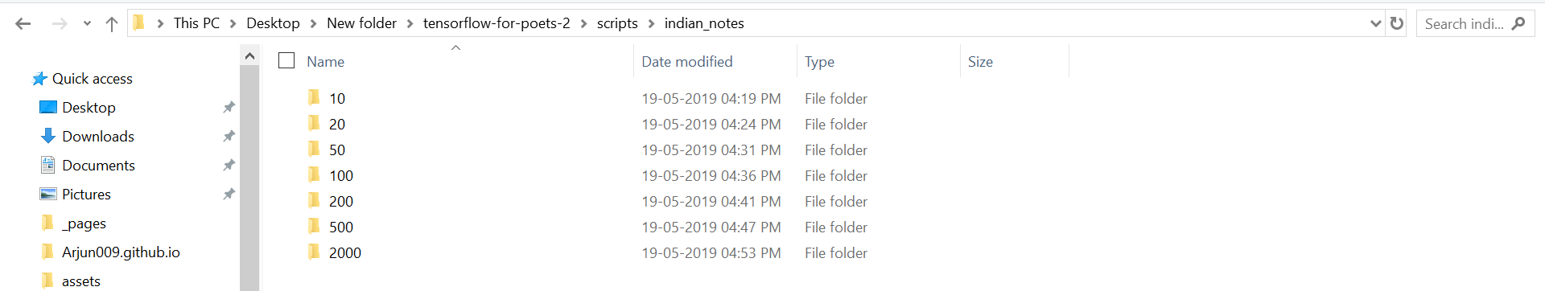

Inside 10,20,50,100,500,2000 folders you need to put your images.

6.) Now go to cmd and current working directory should be in scripts folder.

It should look like this.



Now type in cmd or copy this code snippet

python -m retrain --output_graph=retrained_graph.pb --output_labels=labels.txt --image_dir=indian_notes --architecture mobilenet_1.0_224

**Optional**

Default steps are set to be 4000 with learning rate =0.01 and batch size to train=100.

You can change as your wish by going inside the script.

You’ll find all this thing at the bottom of the script.

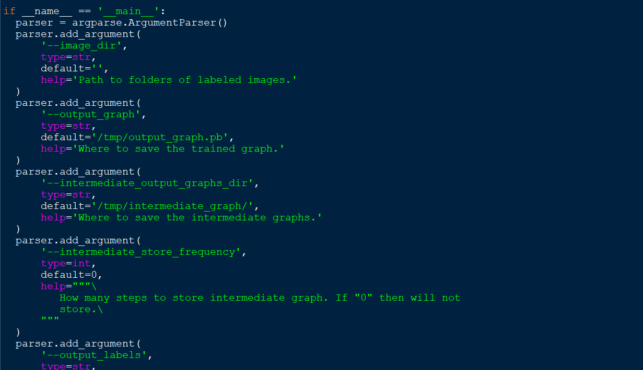

7.) Once done with the step you’ll find labels.txt and retrained_graph.pb in your scrpt folder.

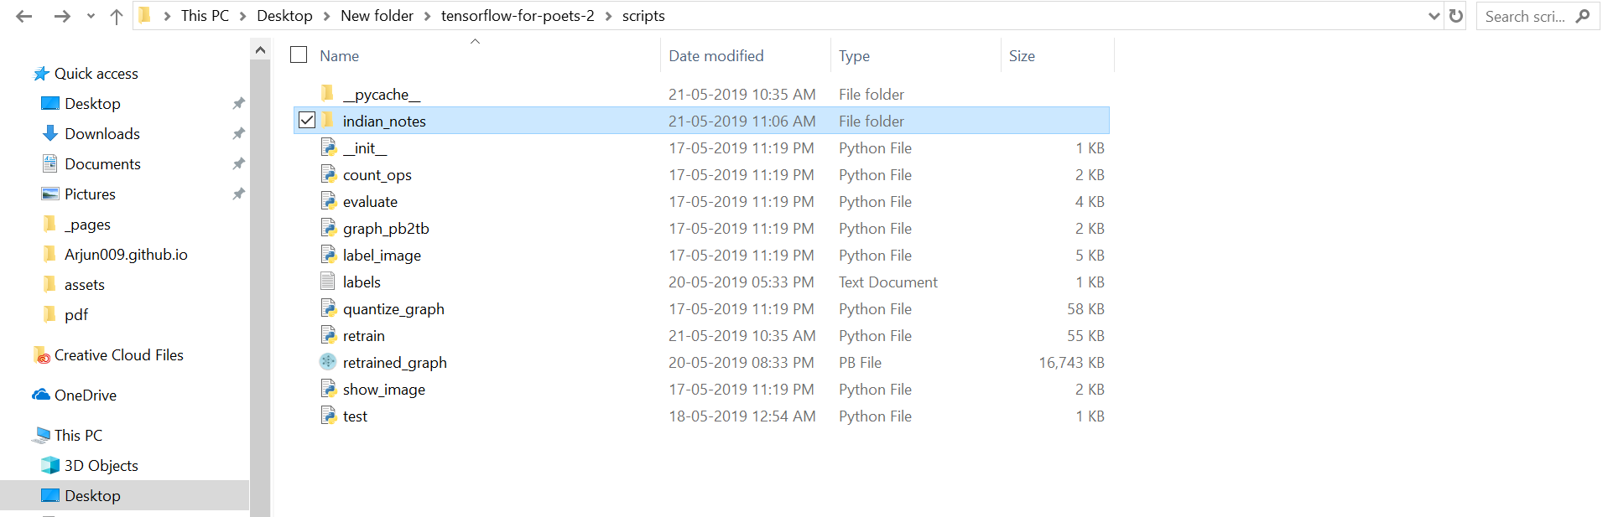

8.) Now run this code snippet in cmd

tflite_convert --graph_def_file=retrained_graph.pb --output_file=optimized_graph.tflite --input_format=TENSORFLOW_GRAPHDEF --output_format=TFLITE --input_shape=1,224,224,3 --input_array=input --output_array=final_result --inference_type=FLOAT --input_data_type=FLOAT

After this you’ll find optimized_graph.tflite file.

9.) Copy this tflite and label

Go to tensorflow-for-poets-2\android\tflite\app\src\main\assets

Inside this assets folder paste this two files. (tflite and label file)

10.) Now go to tensorflow-for-poets-2\android\tflite\app\src\main\java\com\example\android\tflitecamerademo

Here you’ll find **ImageClassifier.java**

11.) Open this in notepad++ or in notepad

Change this line (Line no is 46)

private static final String MODEL_PATH = "graph.lite";

To

private static final String MODEL_PATH = " optimized_graph.tflite ";

12.) Now Follow this step

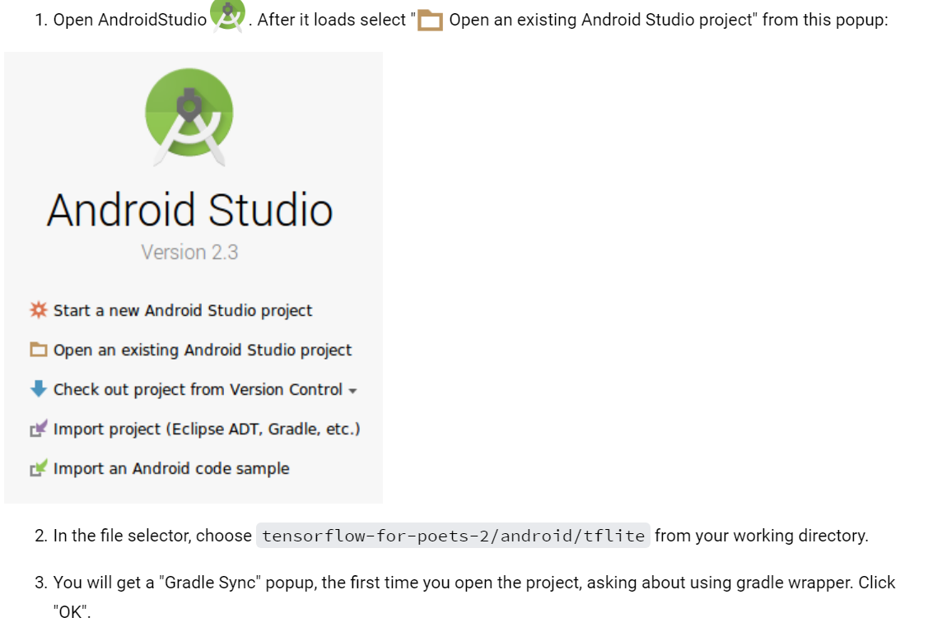

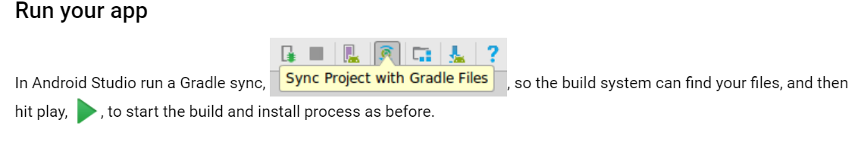

Make sure you connect your phone with usb debugging and select your phone while you will run this app.